1 2 3 4 5

6 7 8 9 10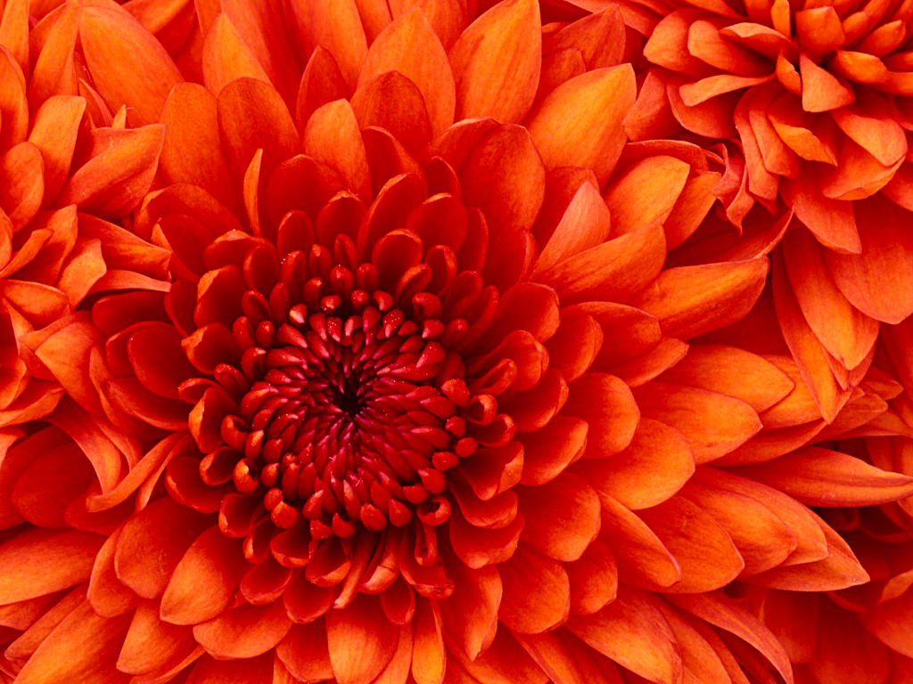

A b c d e

F g h J K

L M N O P

A B C D E F G H I J K L M N O Q R S T U V W X Y Z

0 1

A a+1

2 3

A+2 a+3

AB DU LL AH

01 23 45 67

for(kontrol_bosluk=0;kontrol_bosluk<metin_boyu;kontrol_bosluk++)

{

if(yazi[kontrol_bosluk]==NULL)

{

yazi[kontrol_bosluk]=yazi[kontrol_bosluk+1];

yazi[kontrol_bosluk+1]=NULL;

}

}

|  |  |  |  |  |
| --- | --- | --- | --- | --- |
| A | B | C | D | E |
| F | G | H | I | J |
| K | L | M | N | O |
| P | R | S | T | U |
| V | W | X | Y | Z |

|  |  |  |  |  |
| --- | --- | --- | --- | --- |
| A00 | B01 | D02 | U03 | L04 |
| L10 | A11 | H12 | I | J |
| K | L | M | N | O |
| P | R | S | T | U |
| V | W | X | Y | Z |

|  |  |  |  |  |
| --- | --- | --- | --- | --- |
| 00 A | 01 B | 02 D | 03 U | 04 L |
| 10 H | 11 C | 12 E | 13 F | 14 G |
| 20 I | 21 J | 22 K | 23 M | 24 N |
| 30 O | 31 P | 32 R | 33 S | 34 T |
| 40 X | 41 V | 42 W | 43 Y | 44 Z |